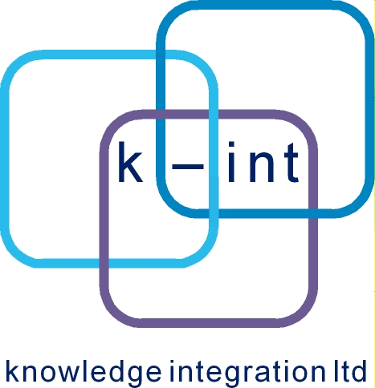

PNDS Discover3 / Culture Grid

Development Plan

Ian Ibbotson
Knowledge Integration
9th March 2009

Table of Contents
1 Overview 3
2 Problem Statement 3
3 Development Aims 3
4 Tasks 3
4.1 Iteration 0 3
4.2 Iteration 1 – March 2009 3
4.2.1 Make a decision about PNDS backend data models 3
4.2.2 Create PNDS-DCAP Handler in Discover3 datamodel project 3
4.2.3 Create E20CL Handler in Discover3 datamodel project 3
4.2.4 Create OAI-DC Handler in Aggregator Core project 4
4.2.5 Configure Aggregator oai-harvest with info from PNDS 4
4.2.6 Create minimal end user search UI 4

Overview
This document sets out the priorities for the development of a culture grid portal which will supercede the existing Peoples Network Discover service.

Problem Statement

Development Aims
The current aim is to have a limited set of complete functionality to show at the end of March. It's critical that what is present is correct, less critical that it's ultra feature rich. We also expect the work to act as a platform for knowledge transfer, and the end of march shoud see rich with an introductory understanding of aggregator projects generally, and the PNDS Discover / Culture grid requirement specifically.

Tasks

Iteration 0
Iteration 0 Constitutes the work done to date and essentially is the contents of svn://developer.k-int.com/home/svn/repositories/default/discover3 which is an initial assembly of all the components needed to create an Aggregator based discover3 / culture grid project.

Iteration 1 – March 2009
Iteration 1 will take the vanilla aggregator framework and adapt it to the following PNDS application profiles:
- PNDS-DCAP
- E20CL
- OAI-DC
Essentially, this involves creating handlers in the datamodel module of the discover 3 project. Once created, we will try to harvest all PNDS datasources from their original setting.
Tasks for Iteration 1

Make a decision about PNDS backend data models
Probably a days work involving Ian, Rob and Rich

Create PNDS-DCAP Handler in Discover3 datamodel project
.5 days for a first version that does identifier, title and description. 3 days for a fuller version.

Create E20CL Handler in Discover3 datamodel project
.5 days for a first version that does identifier, title and description. 3 days for a fuller version.

Create OAI-DC Handler in Aggregator Core project
.5 days for a first version that does identifier, title and description. 3 days for a fuller version.

Configure Aggregator oai-harvest with info from PNDS
2 days admin style work?

Create minimal end user search UI
5 days?

